**The C.I.A. Challenge Solution  
Gabriel Chan Zheng Yong (1002820)**

I received the challenge brief and a file, ‘mrRobotPasokon’.

I read the hint and was told to search ‘robotpasokon’. I did and found a [python module](https://pypi.org/project/PySSTV/) to convert image files to WAV files.



I was told that the file was encrypted and it was from week 1, so I tried to use Caesar’s cipher with bytes (it was a stream of data so I did not choose Vignere’s). I tried different byte values and looked at the first few characters of the file stream. I reasoned that there must be some file header to tell me what kind of file it was. I was specifically searching for some image or WAV files.

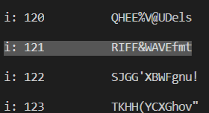

I noticed that 1 entry had some readable characters. So I searched RIFF WAVE and found out it was a WAV file. So I knew that was the right key so I decrypted the file. I used the numbers 121 as I happen to be using ‘encryption mode’ (aka adding the value 121 to the byte instead of subtracting).

Knowing it was a [WAV file](https://drive.google.com/open?id=1WKtUtgkagU-GLFlNrp57DSJB0D1oJU8p), I tried to play it. It made a lot of screechy noises. So I looked into the python module I found earlier. I found out that it was for Slow Scan Television (SSTV). SSTV uses sound to generate an image with the brightness of each pixel proportional to the frequency of the sound. I started looking for a decoder for the file to convert WAV SSTV files to an image but there was very little support for this. I downloaded some Github repositories but they turned out to have missing header files so I could not use them.

After checking with the group again, I was prompted to look at the description of the module again. I noticed this line: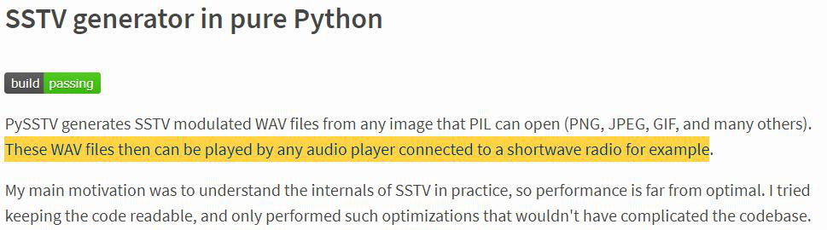

So I tried looking for a receiver instead of a decoder.

After some more research, I found an Android app to receive and produce the image. It’s called [Robot36](https://play.google.com/store/apps/details?id=xdsopl.robot36&hl=en_US). This is what I got:

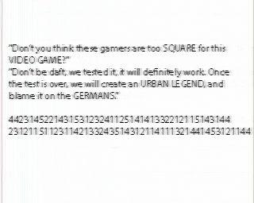

I remember thinking the whole theme the group has chosen is very intense. Next, I tried googling the words in caps. I found this game called [Polybius](https://en.wikipedia.org/wiki/Polybius_(urban_legend)), which was an arcade game from an urban legend. I continued researching, and I found a cipher called [Polybius square](https://en.wikipedia.org/wiki/Polybius_square). It matched the string of numbers given as all the numbers given was from 1 to 5. I tried it, but did not get any plaintext.

So I looked at their hints and tried using a variant of Polybius square called [ADFVGX cipher](https://en.wikipedia.org/wiki/ADFGVX_cipher) which was used by the Germans in World War 1 (since the hint was talking about how germans was getting into the square). It included transposition on top of the polybius square. After trying many variants of the different possible keys, it proved to be a dead end.

I looked closely at what I was given again and realised that I could not use the standard square but must generate a square from a keyword (such as in [Playfair cipher](https://en.wikipedia.org/wiki/Playfair_cipher#Example)). I needed a keyword. I checked with the group and I was prompted to look into the video game and its creator. I found the company, ‘Sinneslöschen’. I used that as a square and finally got the flag! CTF{**theworldhasbeenfooledthisvideogamedoesnotexist**}.

[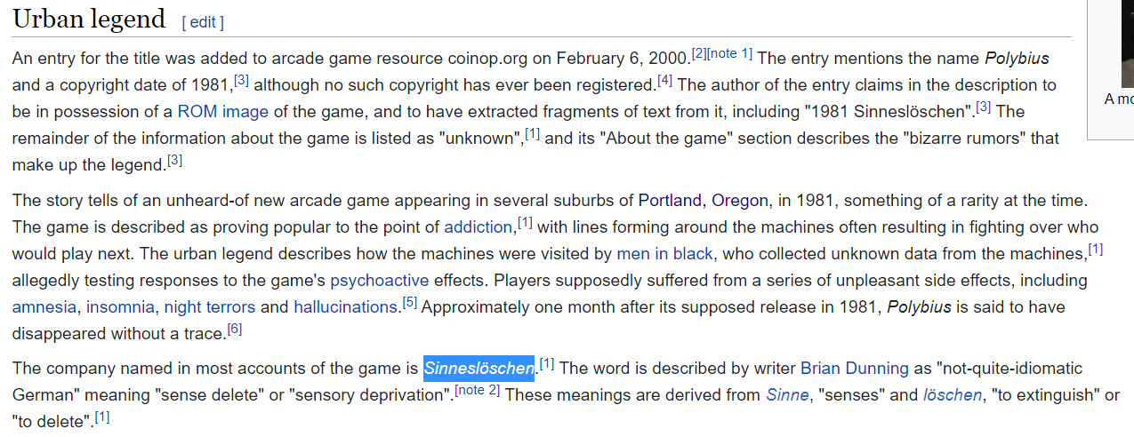](https://en.wikipedia.org/wiki/Polybius_(urban_legend)#Urban_legend)

[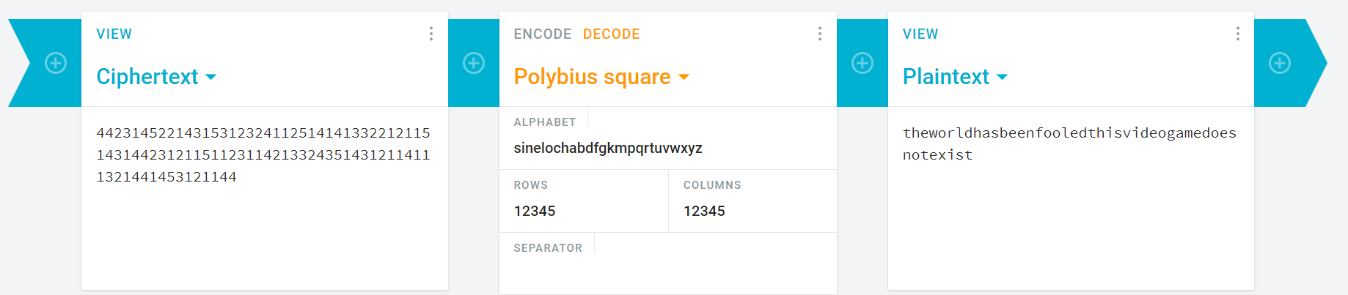](https://cryptii.com/pipes/polybius-square)

(The 2 pictures above are hyperlinks)

I enjoyed this challenge. I learned about SSTV and Polybius square. I did hit a few deadends which wasted quite a bit of time. I need to be more careful with my reading of the hints. Like the team said, everything has been given to me already. Discretion on which lead to follow was also quite a key thing, and I think that would come with experience.